**1. NAT instances**

* A NAT (Network Address Translation) instance is, like a bastion host, an EC2 instance that lives in your public subnet. A NAT instance, however, allows your private instances outgoing connectivity to the internet while at the same time blocking inbound traffic from the internet.

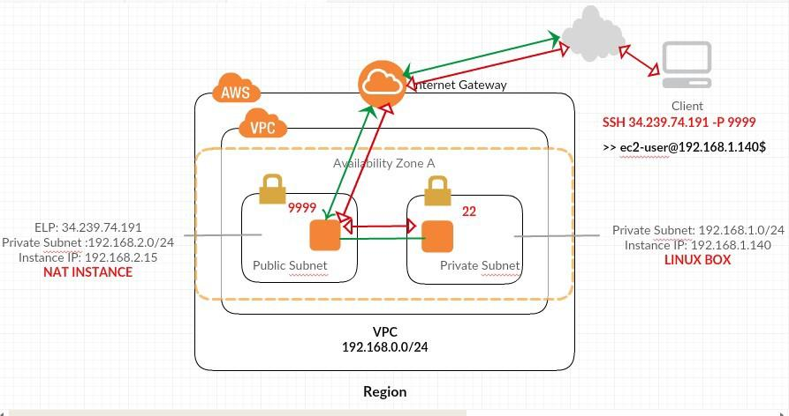

* The following figure illustrates the NAT instance basics.
* The main route table is associated with the private subnet and sends the traffic from the

instances in the private subnet to the NAT instance in the public subnet.

* The NAT instance then sends the traffic to the internet gateway for the VPC.

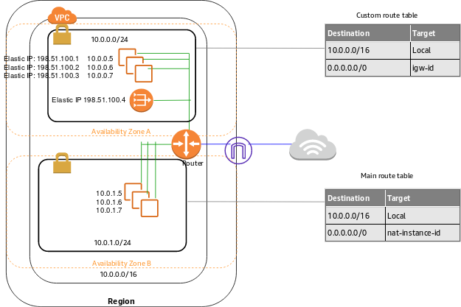

* The traffic is attributed to the Elastic IP address of the NAT instance. The NAT instance specifies a high port number for the response; if a response comes back, the NAT instance sends it to an instance in the private subnet based on the port number for the response.
* Internet traffic from the instances in the private subnet is routed to the NAT instance, which then communicates with the internet. Therefore, the NAT instance must have internet access. It must be in a public subnet (a subnet that has a route table with a route to the internet gateway), and it must have a public IP address or an Elastic IP address.

**1.1 To create vpc , subnet , internet gateway , route table.**

1. **vpc**

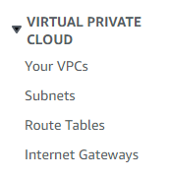







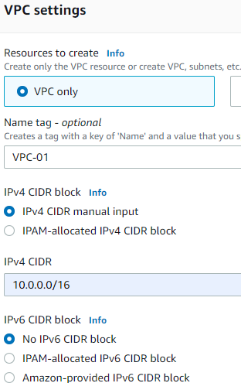

1. **Public subnet.**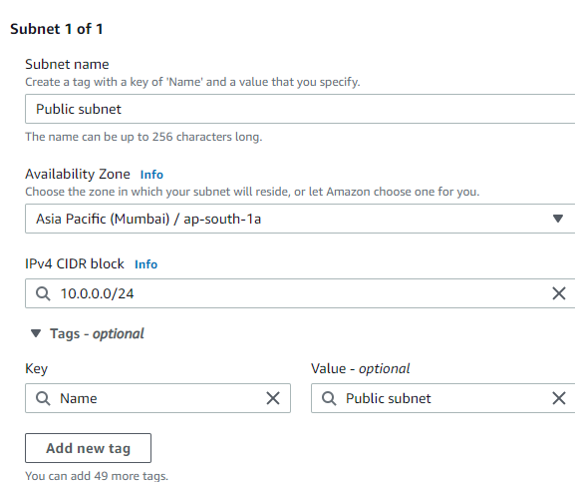
2. **Private subnet .**

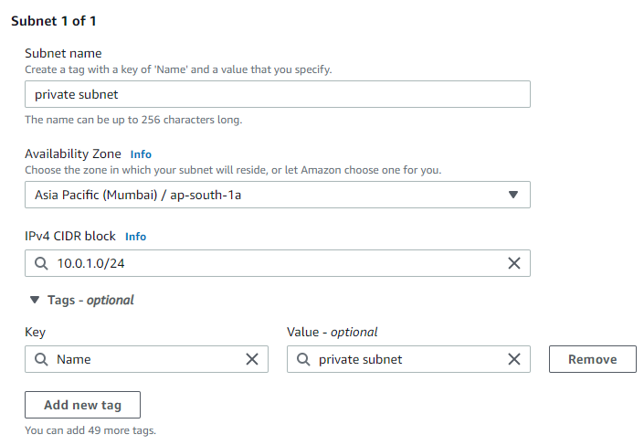



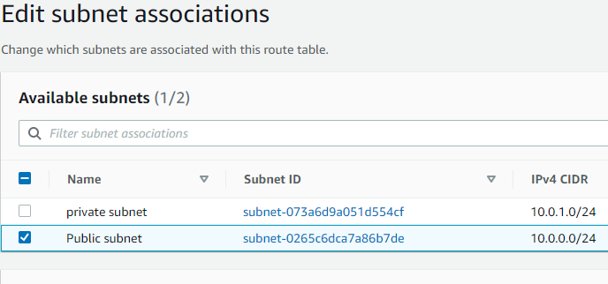

1. **Internet gateway.**

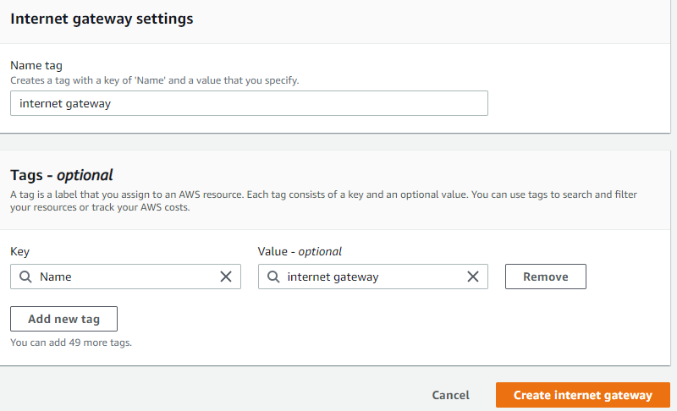

1. **Route table .**

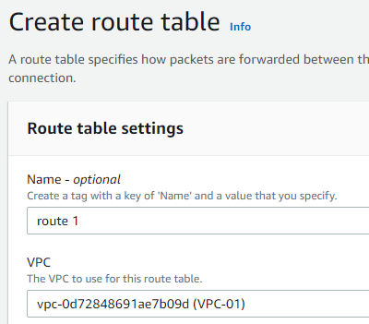

1. Associate the subnet and edit th the route table to internet gateway.

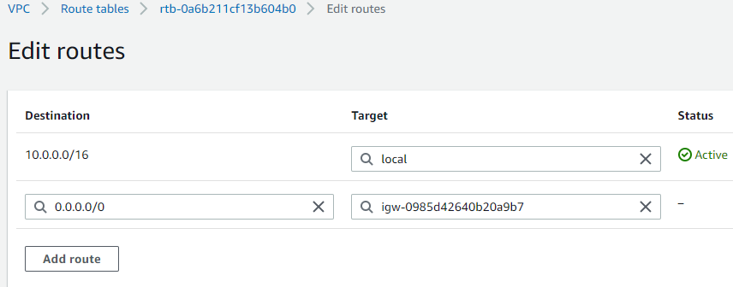

**1.2 Instance amazon ami**











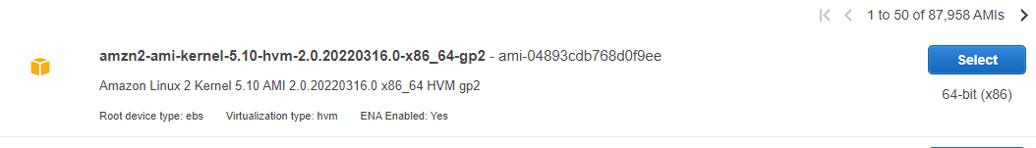







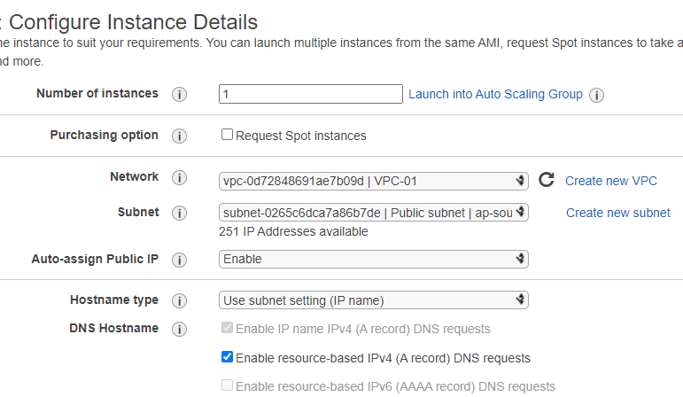



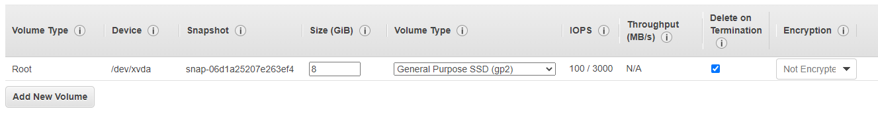



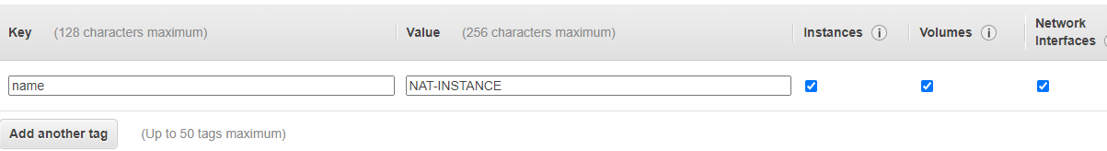



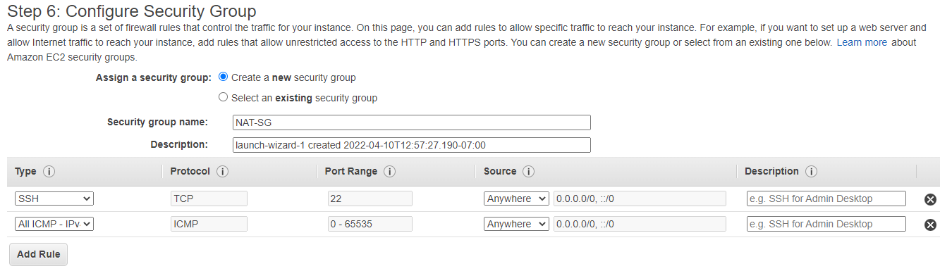



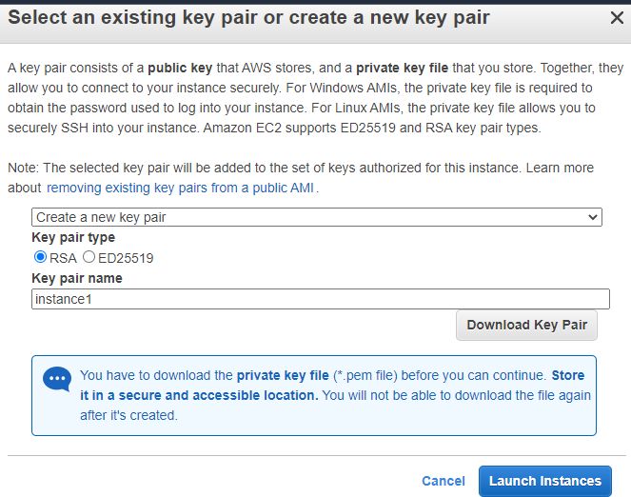

**1.3 Now create linux machine.**



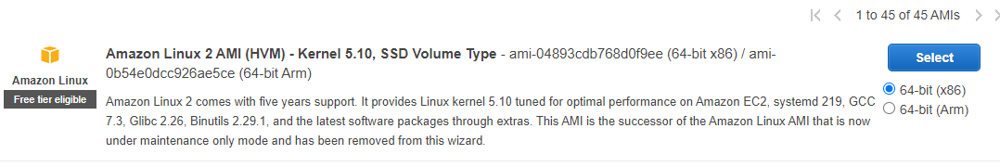







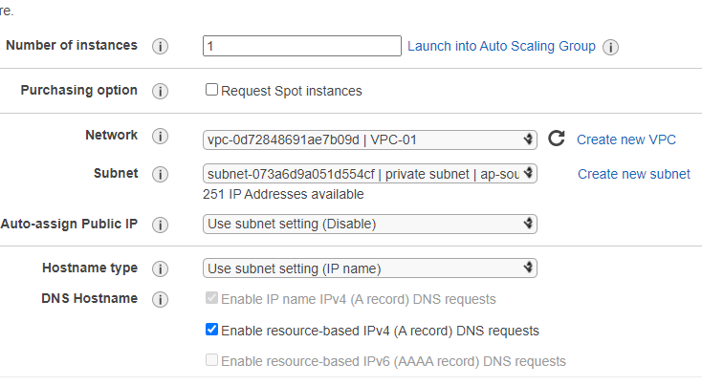



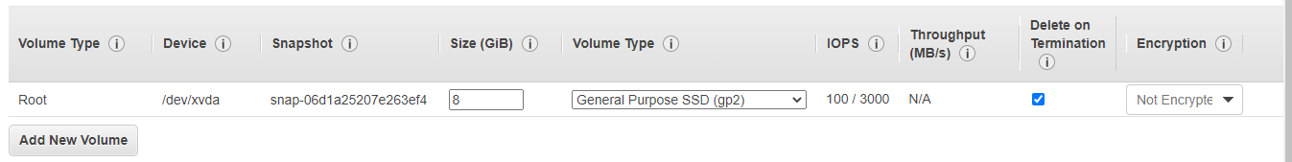



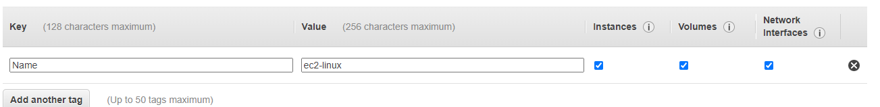



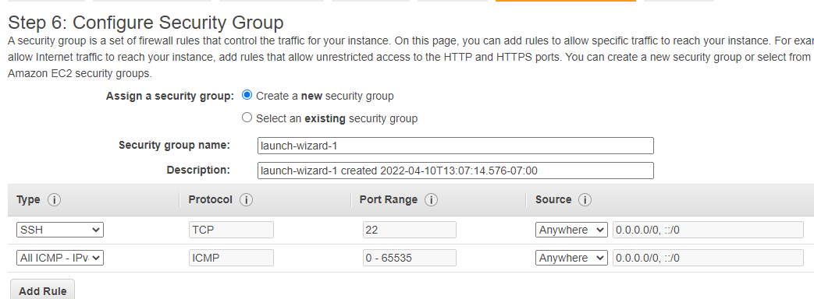



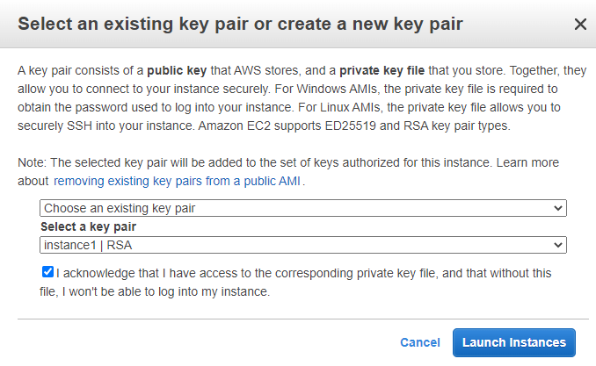



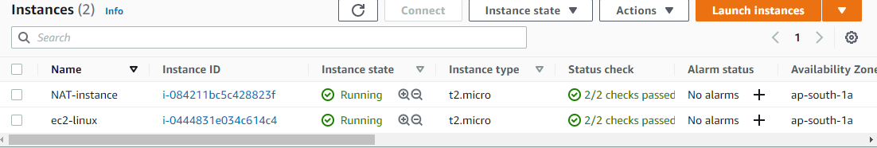



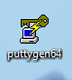

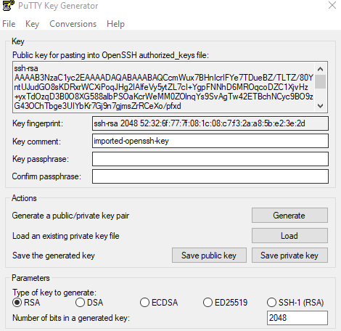

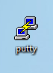

1. 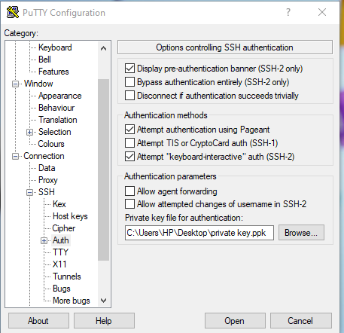

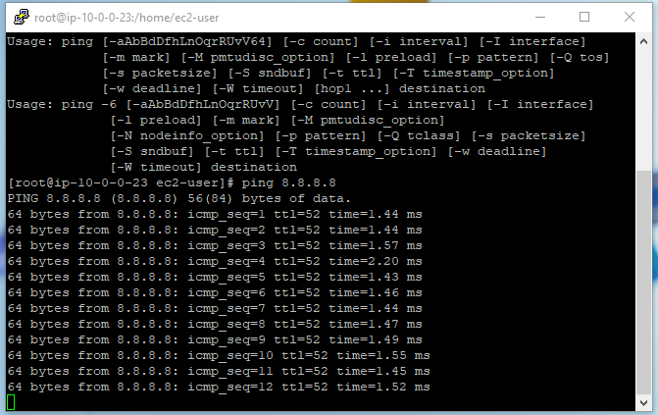

**Steps**

**1)** To create vpc,subnet, internet gateway, route table..

2) To create AMI amazon machine image.

3) To create linux machine

4) To connect linux server with the help of putty and puttygen.

5) command

* ec2-user
* sudo su
* ping 8.8.8.8
* vi gautam.pem
* chmod 700 gautam.pem
* Ssh -1 gautam.pem ec2-user@private ip of linux machine.
* ping 8.8.8.8